Chapter 17, Solution 49.

(a) 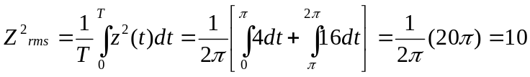

Z_{rms} = 3.162

(b)
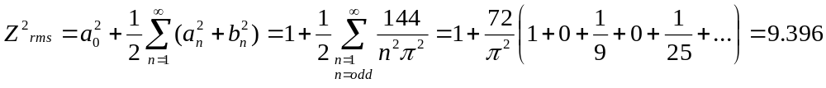
Z_{rms} = 3.065

(c ) 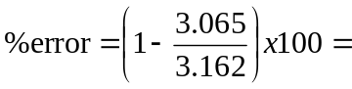 3.068%

